NEW THIS YEAR!!!!

2 Rally trials on Friday!

Loretta “Rusty” Nelson
603 10th Ave No.
Fort Dodge, Iowa 50501

FORT DODGE CANINE COMPANION CLUB
UKC Obedience, Rally & Agility Trials
Fort Dodge, Iowa
Webster County Fairgrounds

Friday, Aug. 6, 2010 Rally Only

Saturday, Aug. 7, & Sunday Aug. 8, 2010
Pre-entries close: 7/28/2010 Midnight
Judges:
Obedience: Keith & Sandra Boeke
Agility: Kathy Davidson
Rally: Lorelle Jones & Sheryl Peterson

2 Days, 4 Obedience Trials!!
Limited to 55 entries per trial.
2 Days, 4 Agility Trials!!
Limited to 100 entries per trial.
1 Day, 2 Rally Trials!!
Limited to 125 entries per trial.

United Kennel Club Certification
Permission has been granted by the United Kennel Club for the holding of these events under the United Kennel Club Rules and Regulations.

Entry Fees: (per class) Pre-entries: $20.00
Same Dog same trial second entry: $15.00
UGRACH (all 3 agility classes one dog): $40.00/ trial
Day of Show entries: $22.00 (per entry)
DOS: Same Dog same trial second entry: $16.00
DOS:UGRACH (all 3 agility classes /dog): $50.00/ trial

Please note:
Obedience, Rally & Agility are separate trials.
(will fill openings first come, first in)
Make checks payable to: FDKC
Mail to: Loretta Nelson
603 10th Ave No
Fort Dodge, Iowa 50501

SHOW SCHEDULE
Friday: Check in & Entries: Open at 9:00 a.m.
Rally Trial 1- 1:30 pm Lorelle Jones – all classes
Rally Trial 2- 2:30 pm Sheryl Peterson – all classes
Please note rally trials are running concurrently in two separate rings
Saturday: Check in & Entries: Opens at 7:00 a.m.
Obedience Sat: Trial 1-9:00 am- Keith Boeke-Utility B,Utility A, Open B, Open A, Novice C, Novice B, Novice A
Trial 2-10:00 am-Sandra Boeke-Utility B, Utility A, Open B, Open A, Novice C, Novice B, Novice A
Agility Sat: 8:30 am- Kathy Davidson -Trial 1 AgII, Trial 2 AgII, Trial 1 AgIII, Trial 2 AgIII, Trial 1 AgI, and Trial 2 AgI
**Please note agility trials run concurrently
Sunday: Check in & Entries: Open at 6:30 a.m.
Obedience Sun: Trial 3-8:30 am- Keith Boeke-Utility B,Utility A, Open B, Open A, Novice C, Novice B, Novice A
Trial 4-9:00 am- Sandra Boeke-Utility B, Utility A, Open B, Open A, Novice C, Novice B, Novice A
Agility Sun: 8:00 am-Kathy Davidson –Trial 3 AgI Trial 4 AgI,Trial 3 AgIII Trial 4 AgIII, Trial 3 AgII, Trial 4 AgII

You MUST check in 1 hour prior to the start of judging for their class.
Dogs MUST have a UKC registration or listing # to be entered.
REFUNDS: Requests received prior to closing date will be honored, subject to a $5.00 administrative fee.

Entry fees will not be refunded in the event a dog is absent, disqualified, excused by judge or veterinarian, barred from competition by action of the show committee or UKC. No fees will be refunded if the Show cannot open or be completed by reason or riots, civil disturbances, fire, extreme &/or dangerous weather conditions, an Act of God, public emergency or any other cause beyond the control of the show committee.

Returned Checks do NOT constitute valid entry fee. The club will add a $25.00 fee for each returned check.
The Show giving club, their agents & employees, etc., assume no responsibility for any loss, damage or injury sustained by exhibitors, handlers, or to any of their dogs or property.

The show site will be open at 12:00 noon Fri.
and at 6 am. Sat. & Sun.
Crating space available indoors.
Only exhibitors that have dogs entered in obedience or agility may leave crates overnight (at your own risk).
Rally only exhibitors must remove crates.
NO DOGS may be left overnight.
For More Information:
Loretta "Rusty" Nelson (515)573-3020

email: rustyn1@live.com
Food & Beverages.
There will be concessions available at the show site.
AWARDS
1st-4th place Ribbons in each class each trial
High in Trial Prizes offered for each trial
High Combined Ribbons
High Score Junior Handler (please register)
New Title Awards

This site is air-conditioned. There is a SEPERATE area for obedience connected by a hallway to the area for agility. All rings will be fully matted.

From I35 take US 20 west to US 169N. Take second exit left to frontage road (old highway 169) Turn right. Follow fairground signs 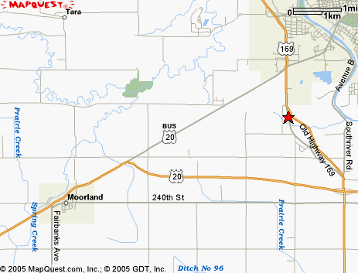
Motels: Budget Host (515) 955-8501
Super 8 Motel (515) 576-8000
Comfort Inn (515) 573-3731

